CREATING CUSTOM DOMAIN NAME WITH ROUTE 53 FOR WEBPAGE

1. Create a hosted zone In Route 53 aws service. With custom Domain name.

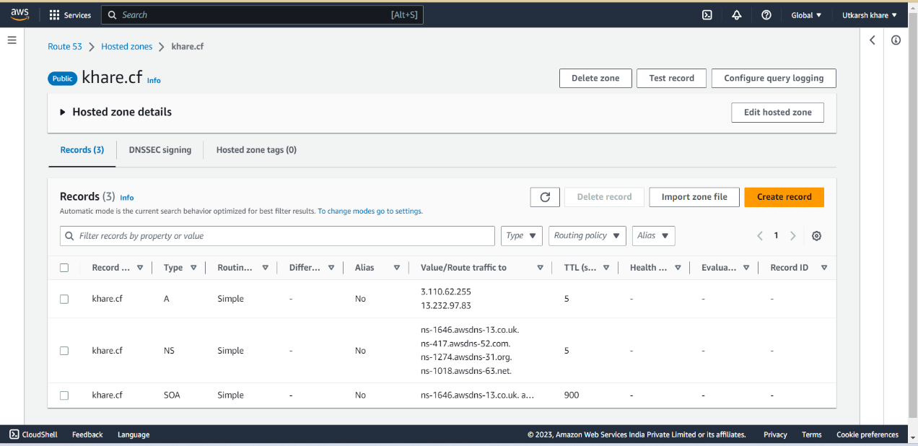

1. Login in to your registered website where domain name registered, in my case “freenom” and update the nameserver. Which is generated after creation of Hosted zone.(highlighted in red box).

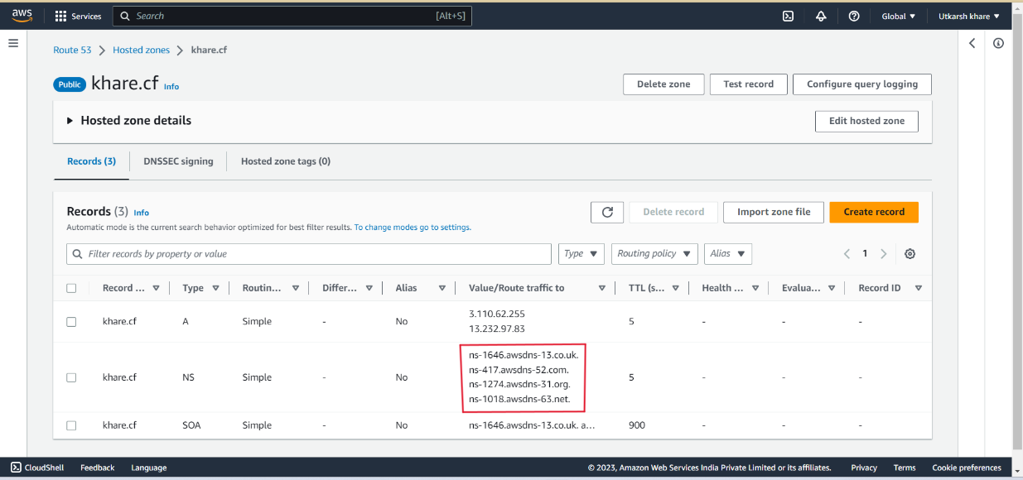

1. Create a new record with your “Host 1” and “Host 2” ip address.

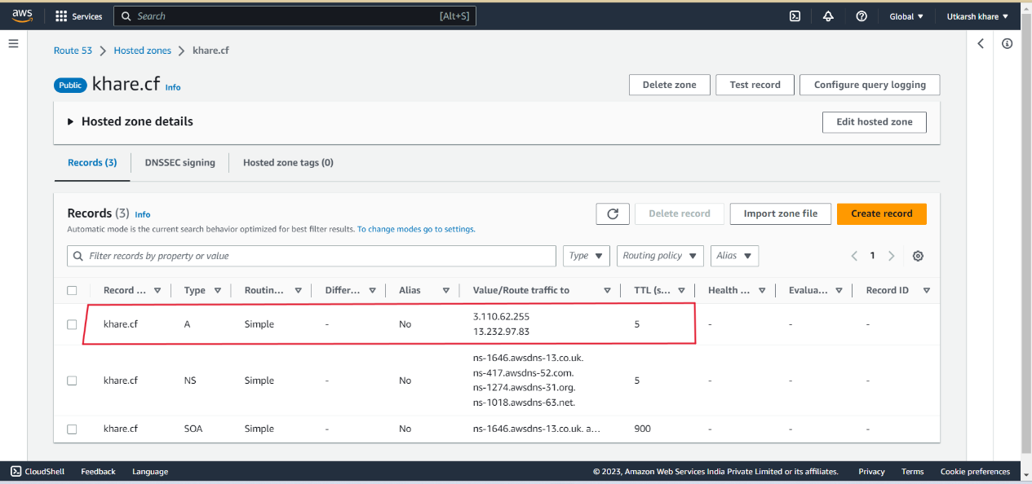

1. After few seconds access your website by :- <http://host-name/picstudio>/ (in my case :- <http://khare.cf/picstudio/> )

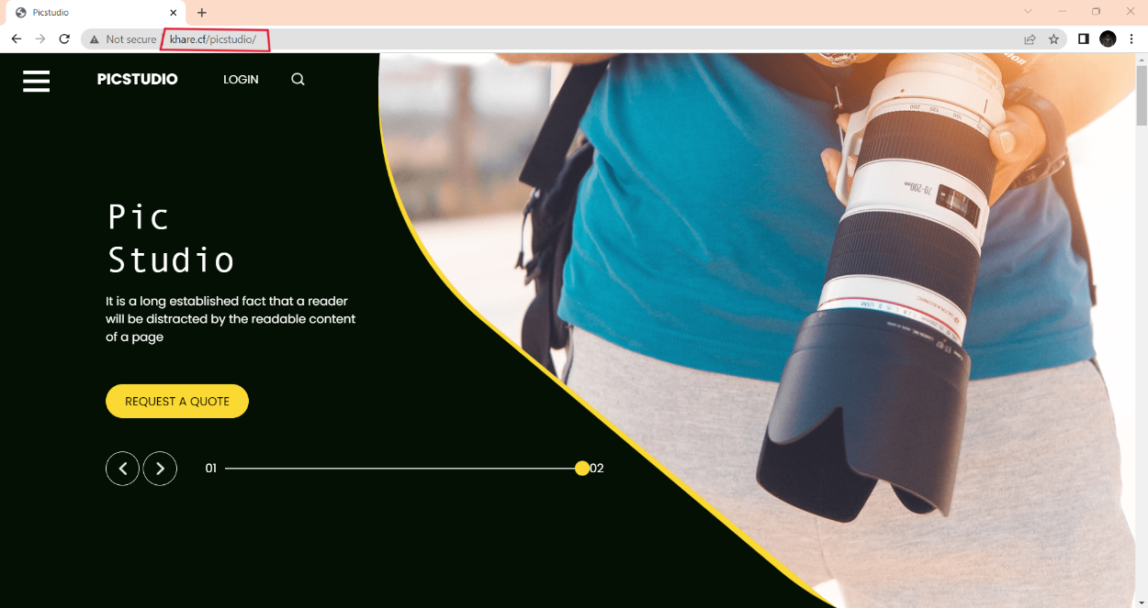

Website is now running on a custom domain name behind a load balancer 😊